KMC Hackathon 1.0 Project Report Project Title: Community QR Board
Team Name: Underside
Team Members: Sparsh Shrestha, Nirvan Bikram Adhikari, Simon Tiwari, Raunak Dhakal
Team's Github Repository:

Mentor: _______Santosh__Sir______

1.Abstract
Traditional paper-based notice boards will be replaced by a digital platform called the QR-Based Community Notice Board. Users can quickly access updated community notices on their mobile devices by scanning a QR code. Using a secure admin panel, administrators can quickly add, modify, or remove notices. Everyone in the community can access information more easily thanks to this system, which also guarantees quicker communication and less paper waste.

2.Statement of the Problem
Conventional community notice boards use printed notices, which are frequently out-of-date, broken, or disregarded. It takes time, effort, and physical presence to update these notices. Due to low visibility and a lack of real-time updates, significant announcements frequently miss their deadlines in communities. A straightforward, affordable, and easily accessible digital notice system is required.
3.Existing System
- Physical notice boards using paper notices
- Manual posting and removal of notices
- No real-time updates
- High paper usage
- Notices can be lost, torn, or overwritten
- Limited reach and accessibility

4.Proposed Solution
The proposed system uses a QR code placed in public areas. When scanned, it redirects users to a digital notice board webpage. Administrators manage notices through a separate login-based admin interface. The system allows instant updates, centralized management, and easy access without requiring users to install any application.
5.Objectives
- To digitize community notice boards
- To reduce paper usage and maintenance cost
- To provide real-time notice updates
- To ensure easy access through QR scanning
- To create a user-friendly admin and user interface
6.Technology Used
- HTML, CSS, JavaScript
- Admin login system
- Generated using online QR tools
- GitHub Pages
7.System Wireframe

Figure 1: Admin's interface Wireframe

Figure 2: User's interface Wireframe

8.Results
- Successfully created a working QR-based notice system
- Notices update instantly without physical effort
- Users can access notices easily using smartphones
- Admins can manage notices efficiently

9.Advantages
- Paperless and eco-friendly
- Low cost and easy to deploy
- No app installation required
- Real-time updates
- Easy maintenance
- Accessible to all age groups

10.Limitations
- Requires internet connection
- Smartphone needed to scan QR code
- Basic security depending on implementation
- Limited offline functionality

11.Future Improvements
- Offline access using cached notices
- Push notifications for urgent alerts
- Multi-language support
- Role-based admin system
- Analytics for QR scan count
- Integration with SMS or WhatsApp alerts

12.Conclusion
The QR-Based Community Notice Board provides a modern and efficient solution to traditional notice systems. It improves accessibility, reduces environmental impact, and ensures timely information delivery. With further enhancements, this system can be widely adopted in schools, residential societies, public offices, and smart city initiatives.

Workflow Diagram

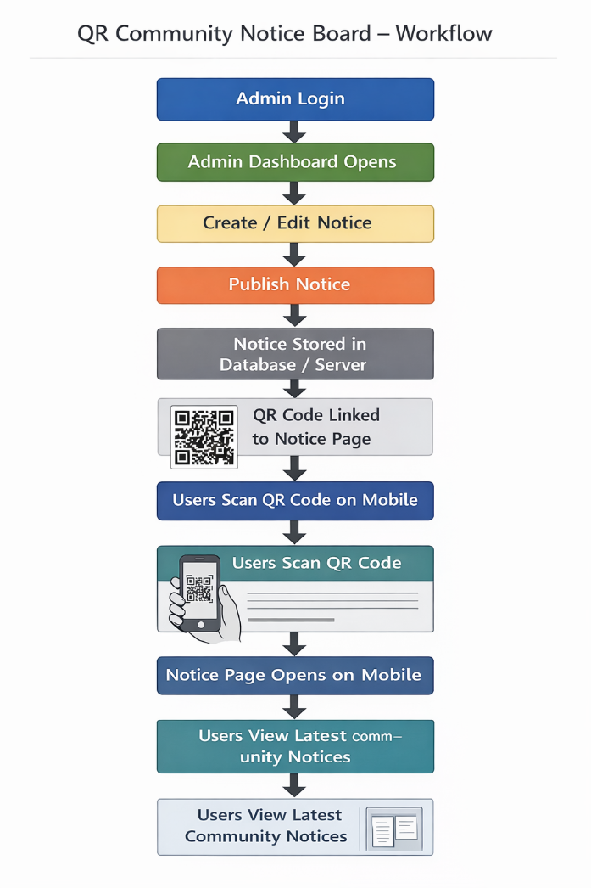

Wireframe Diagram

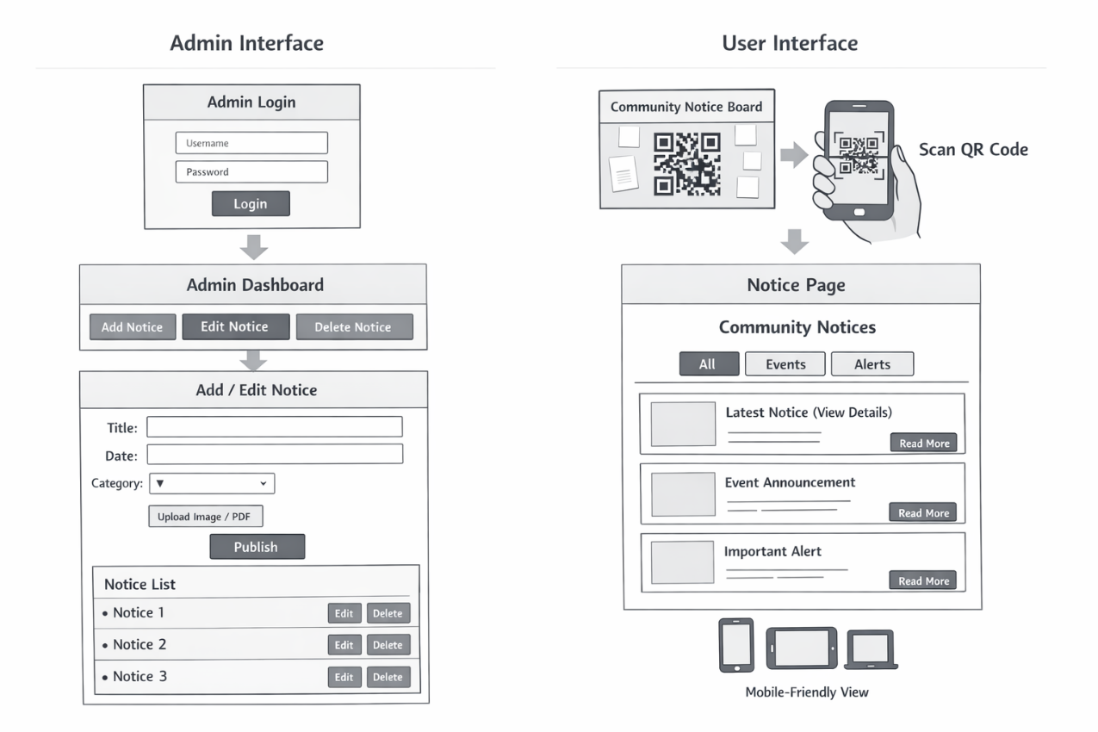

Thank you!!!

